# 03. Chain Lightning

Please submit your solutions (source code) of all below-described problems in [Judge](https://judge.softuni.org/Contests/3474).

You are given all neighborhoods in Sofia and the distances between them. A thunderstorm is raging above the city with lightning strikes falling all around.

When lightning falls, it **damages all connected neighborhoods**, but the damage **halves** with each jump (integer division). The lightning alwaysjumpsto a neighborhoodthat has the **smallest distance to** **any neighborhood already damaged**. Note that lightning doesn’t necessarily fork only at its tail. Also, the same lightning **cannot damage** the sameneighborhoodtwice.

Consider the example: lightning falls on the **1st** neighborhood with full force, then jumps to the **3rd** (distance to **1st** is smallest) with its damage halved. After that, the nearest one is the **2nd** (distance from first is 10, damage also halved) and lastly, it jumps to the **4th** from the **2nd** (15 < 20) with **initial damage** divided by 2 and then divided by 2 again.

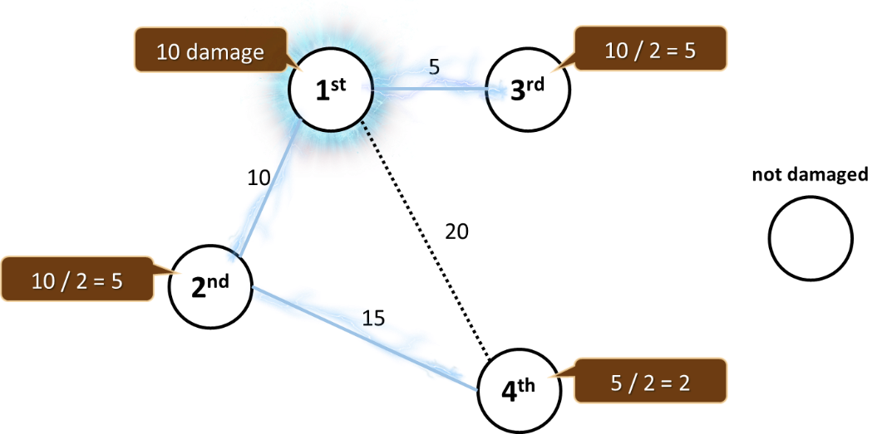

Your job is to find the condition of the most heavily damaged neighborhood after **multiple strikes** on top of different city neighborhoods, so a team of highly skilled technicians can be dispatched.

## Input

* The **first line** holds an integer **n** – the number of neighborhoods
* On the **second line**, you will receive the number **m** – the number of distances
* On the **third** **line**, **l** - the number of lightning
* At the next **m** **lines**, you will receive the distances: **{from neighbourhood} {to neighbourhood} {distance}**
* At the next l lines, you will receive the lightning strikes: **{neighborhood} {damage}**
* The neighborhood will always be numbered from **0** to **N - 1**

## Output

* Print the condition of the most heavily damaged neighborhood

## Constraints

* The number of neighborhoods will be an integer in the range [**0**…**5000**]
* The number of connections will be an integer in the range [**0…10000**]
* The number of lightning strikes will be an integer in the range [**0…1000**]
* Distance between neighborhoods will be a **unique** integer in the range [**0…100000**]
* Lightning damage will be an integer in the range [**0…1000**]
* Time limit: **200 ms**. Allowed memory: **32 MB**

## Examples

|  |  |  |  |
| --- | --- | --- | --- |
| **Input** | **Output** | **Visual** | **Comment** |
| 5  5  2  0 1 10  1 4 20  2 4 30  0 2 35  0 3 50  0 40  4 20 | 45 |  | There are two lightnings.  First lightning (0 40):  0 🡪 40  3 🡪 20  1 🡪 20  4 🡪 10  2 🡪 5  Second lightning (4 20):  4 🡪 20  2 🡪 10  1 🡪 10  0 🡪 5  3 🡪 2  0 is most heavily damaged |

|  |  |  |
| --- | --- | --- |
| **Input** | **Output** | **Visual** |
| 10  8  3  0 1 5  1 2 4  1 3 6  2 3 3  2 5 7  2 4 2  7 6 8  7 8 1  2 100  0 200  9 100 | 225 |  |